# Exercise: Bootstrap

# IRunes

Problems for exercises and homework for the ["C# Web Basics" course @ SoftUni](https://softuni.bg/courses/csharp-web-development-basics). Yoy can submit your solution in the course web page.

In the previous exercise you should have implemented the **IRunes** **application** – a simple **music store application**. Due to the fact that **exceptional design** was **not required**, the pages, which the application supported, were implemented – using only HTML. Thus, they looked like something implemented 50 years ago – ugly and simple.

But this time, the case is different... We now have a powerful friend to our side – **Bootstrap**. Let’s use it to make the pages more beautiful.

# Database Requirements

You have been tasked to implement a simple application, using the Web Server. The application imitates a **store** for **Music Albums** and **Music Tracks**. You will see the functionality – described below.

The first thing you need to do is implement the Database entities. Use Entity Framework Core, and implement the following entities:

## User

* Id – a **string** (**GuID**).
* Username – a **string**.
* Password – a **string** (**encoded** in the database).
* Email – a **string**.

## Album

* Id – a **string** (**GuID**).
* Name – a **string**.
* Cover – a **string** (a **link** to an **image**).
* Price – a **decimal** (**sum** of all Tracks’ **prices**, **reduced** by **13%**).
* Tracks – a **collection** of Tracks.

## Track

* Id – a **string** (**GuID**).
* Name – a **string**.
* Link – a **string** (a **link** to a **video**).
* Price – a **decimal**.

# Initial Configuration

But is our Server capable of handling resource requests? Because requesting bootstrap.css is a resource request, which must be handled differently. Well, let’s configure it to do so.

## Resources Folder

The Resources Folder will be in the Application Project. Each application has its own resources.

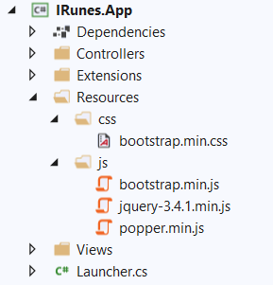

**Create** the **folder** and **divide** the **different resources**. (**download** the files shown above, locally, from their respective sites). **NOTE**: There is **no particular meaning** to the resource files being separated into folders named as the resources’ extensions, it’s just well-structured resource folder.

## Inline Resource Result

First, we need to create a Response, which will be returned with the Resource File Contents.

Create a class named InlineResourceResult, which we will use for that purpose. It should look like this:

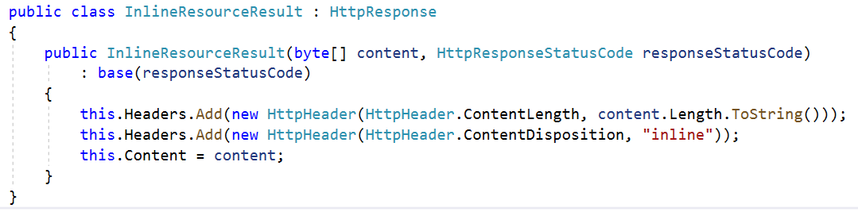

As you can see the content given in the constructor is byte[]. That’s because the resource might be a media file. For example: favicon.ico.

We also set the Content-Length and Content-Disposition Headers. The Content-Disposition is inline, as this particular Result class is used to **return** only **inline resource**, which are used in the web pages.

**NOTE**: It is not quite good to depend on the **Client’s** **Browser** to set the Content-Type header for you, but for now we will. (Will be fixed in the future).

## ConnectionHandler

The other class we need to change is the ConnectionHandler. Particularly, the way Requests are **Handled**.   
Modify the HandlerRequest() method to look like this:

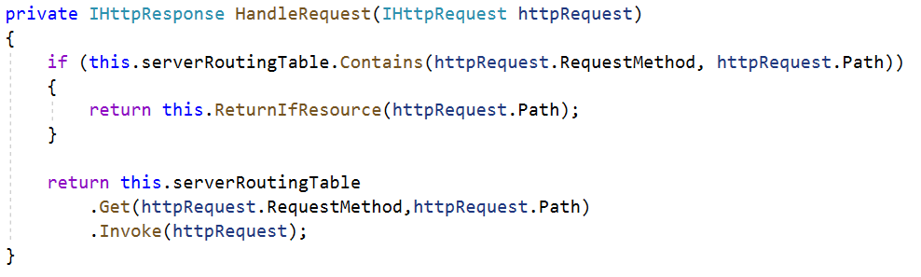

The ReturnIfResource() method should check for a **resource** with the **given name** (in the path of the Request, for example: /css/bootstrap.min.css), in the Resources folder of the Application.

* If there is, an InlineResourceResponse should be returned, with the Resource File’s contents.
* If there isn’t, a Not Found HttpResponse should be returned.

However, the method’s **implementation** is up to **you**. 😊

# Templates

You will be shown how the **template looked before**, and **how it should look now**. Style it **using Bootstrap**, to match the given screenshot. Be as precise as you can.

## Index (guest, logged-out) (route=”/Home/Index”, route=”/”)

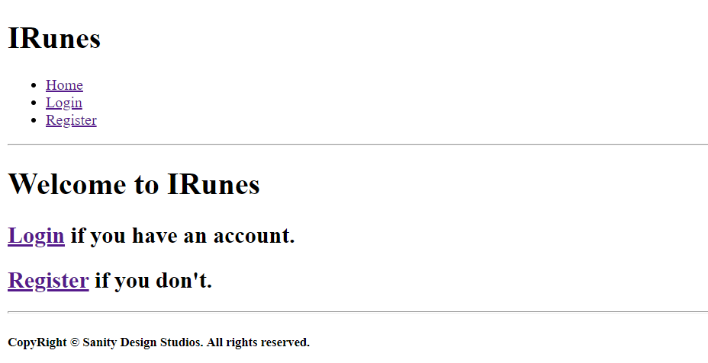

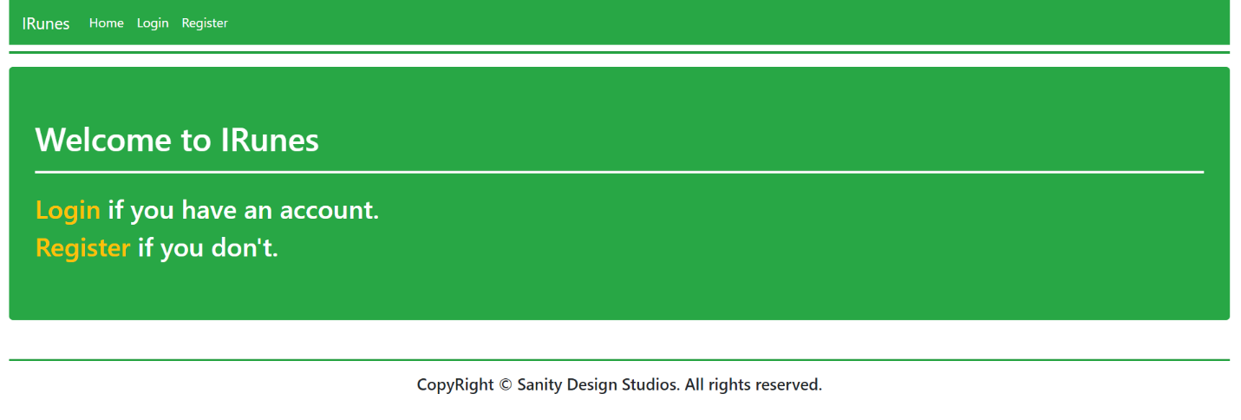

## Login (guest, logged-out) (route=”/Users/Login”)

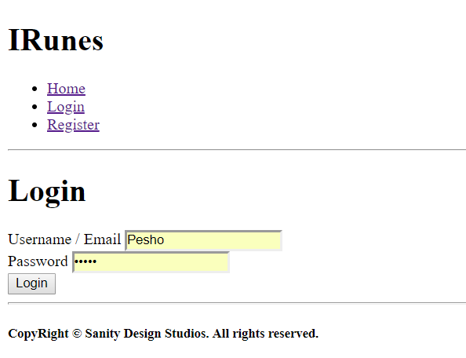

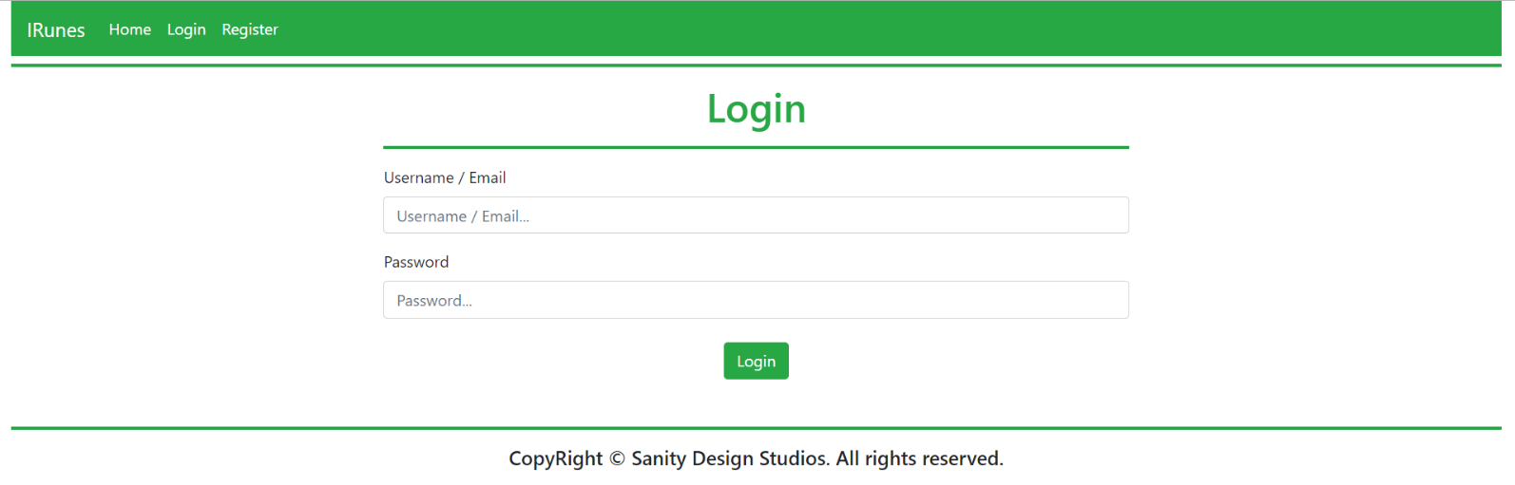

## Register (guest, logged-out) (route=”/Users/Register”)

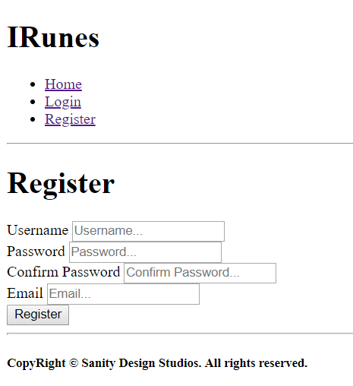

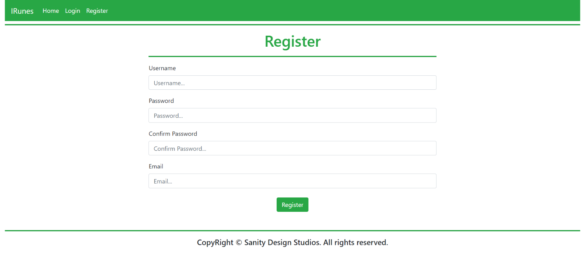

## Index (user, logged-in) (route=”/Home/Index”, route=”/”)

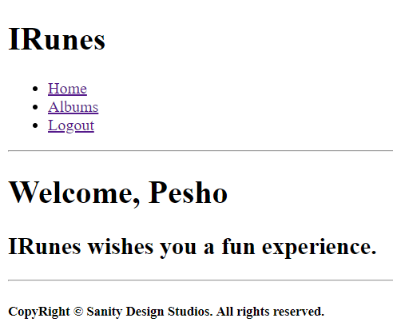

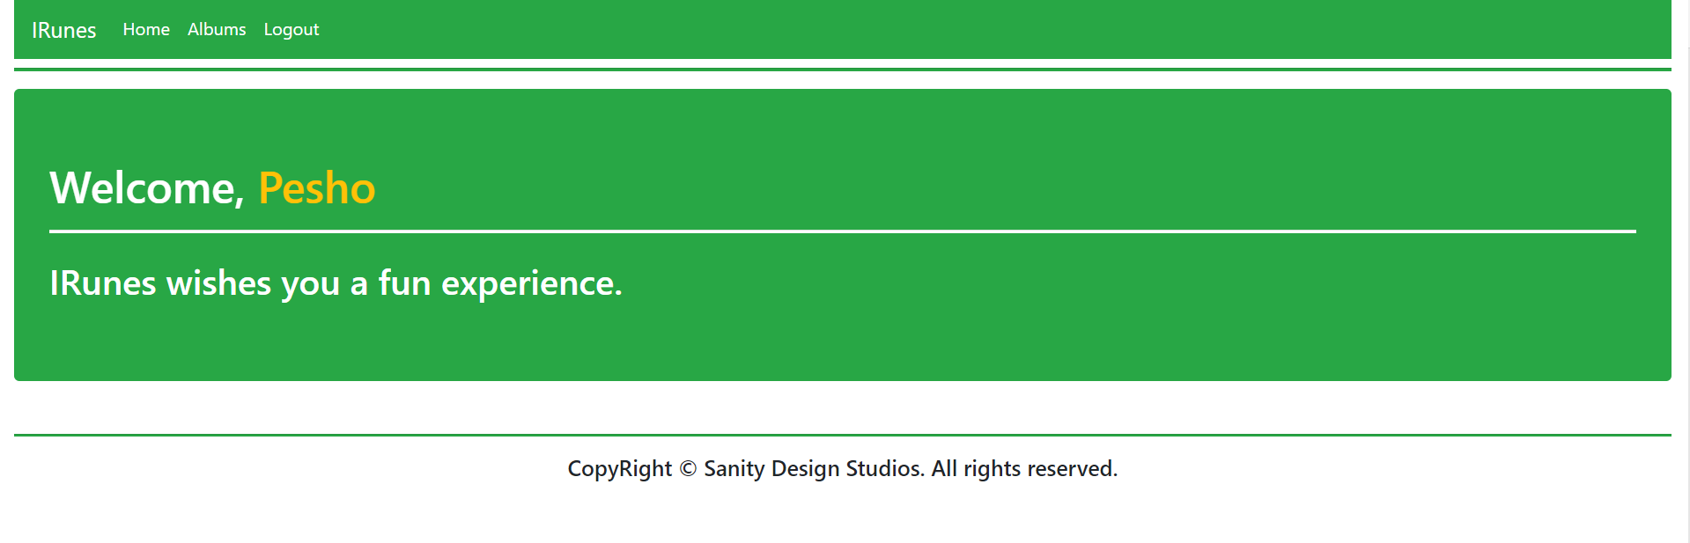

## All Albums (user, logged-in) (route=”/Albums/All”)

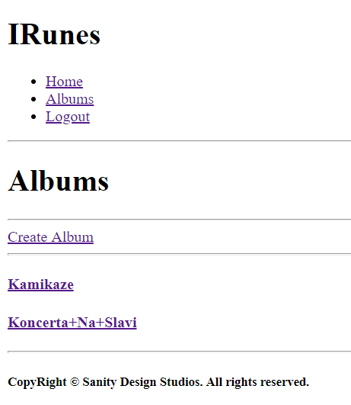

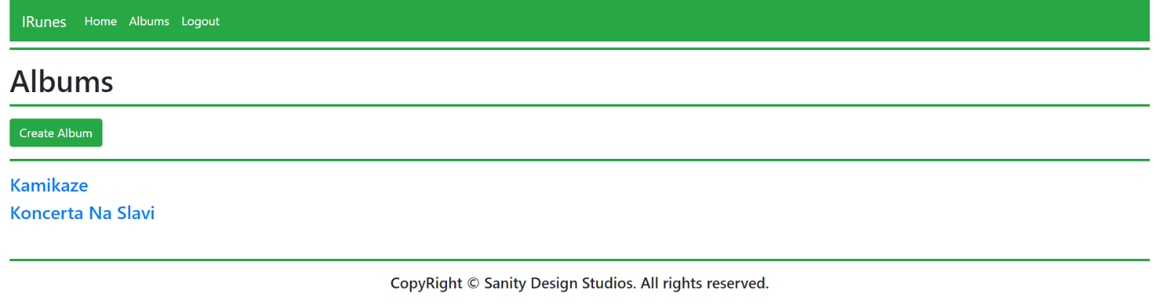

## Album Create (user, logged-in) (route=”/Albums/Create”)

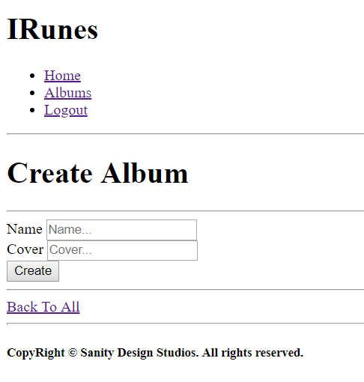

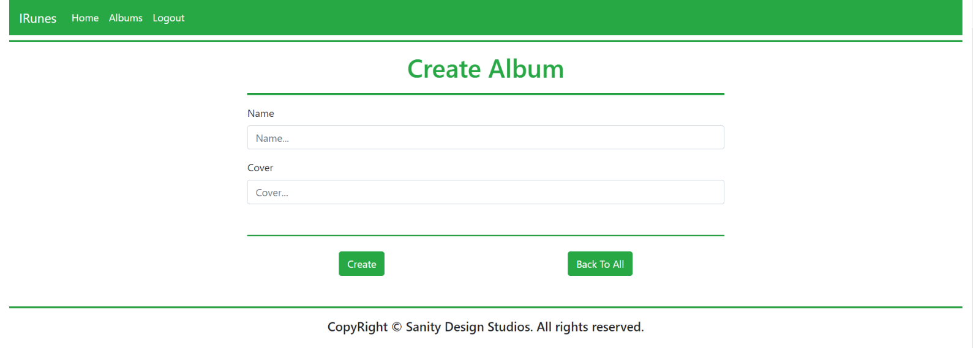

## Album Details (user, logged-in) (route=”/Albums/Details?id={albumId}”)

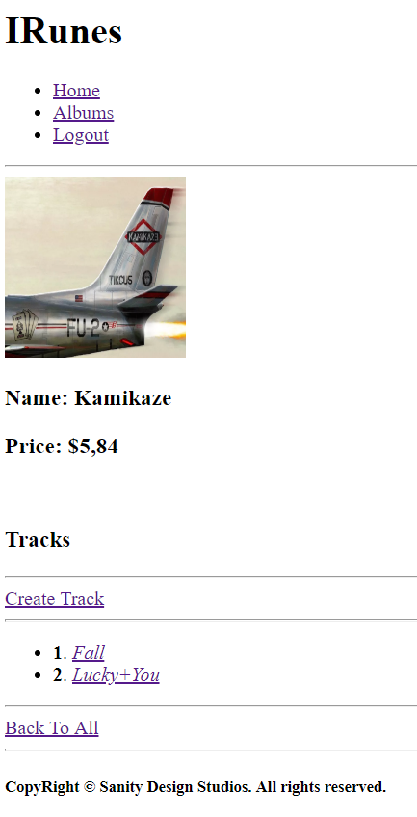

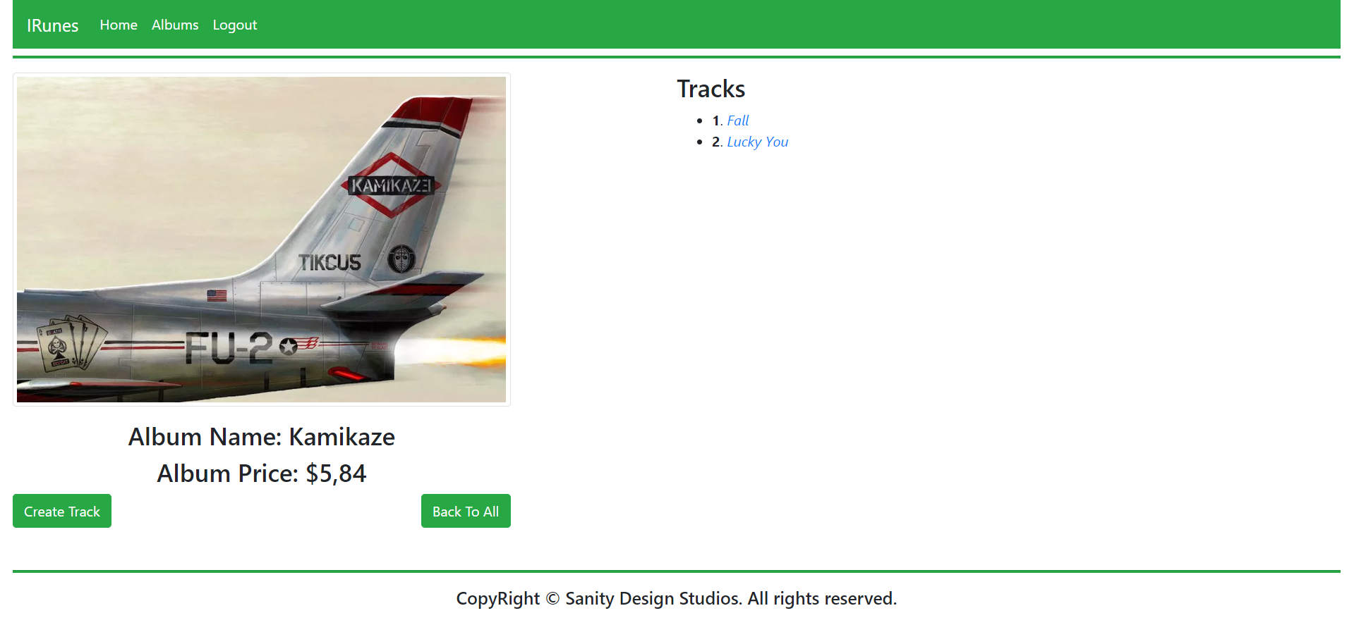

## Track Create (user, logged-in) (route=”/Tracks/Create?albumId={albumId}”)

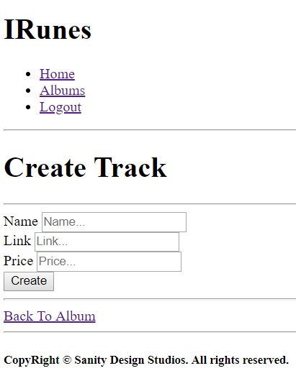

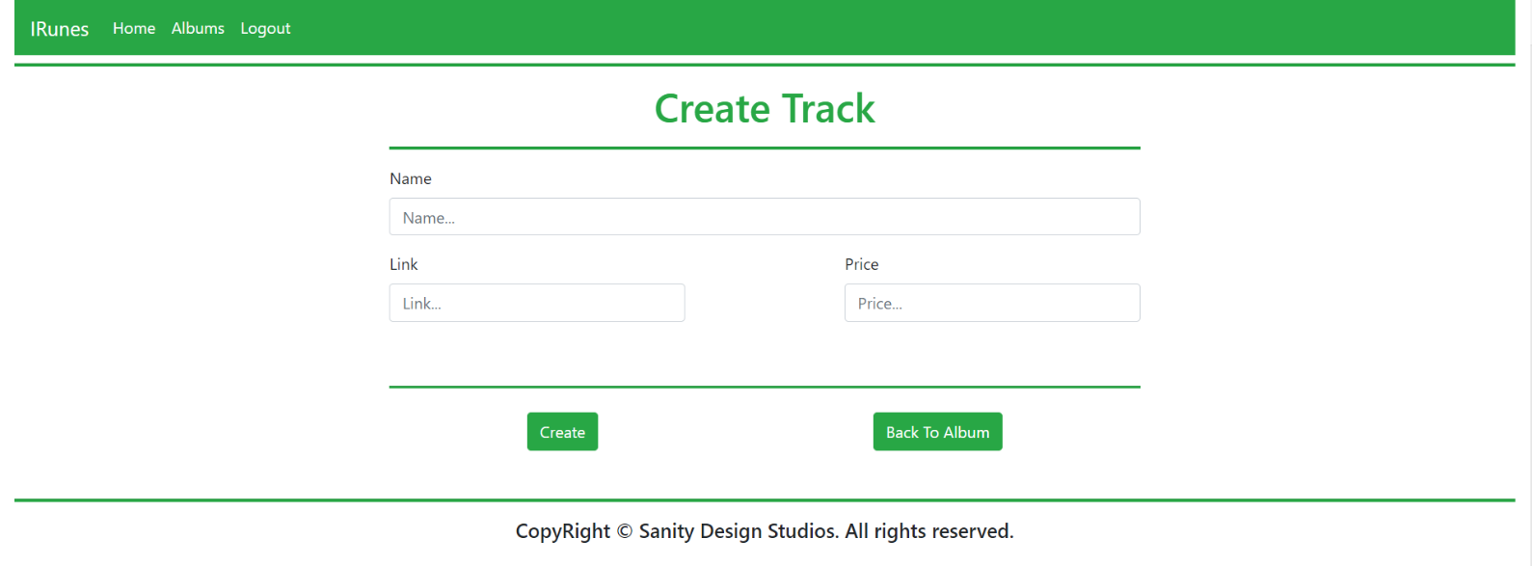

## Track Details (user, logged-in) (route=”/Tracks/Details?albumId={albumId}&trackId={trackId}”)

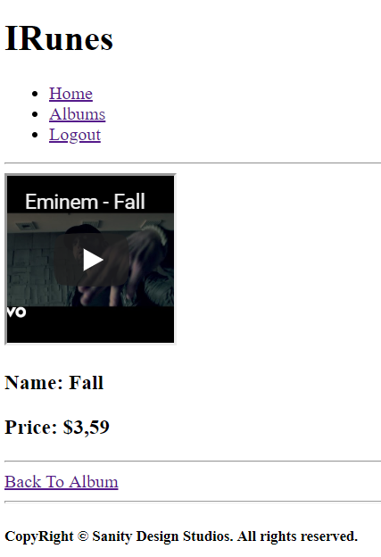

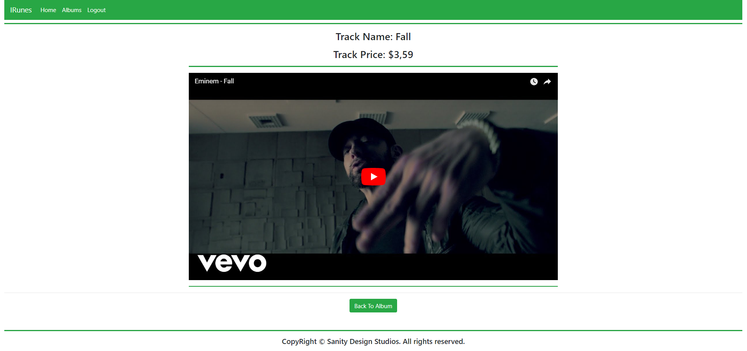

## Hints

If you don’t know how to do something, just search for it on the internet. The **Bootstrap Documentation** and **Community** are quite helpful.

# Bootstrap does not provide style for Horizontal lines (<hr />). To implement the lines shown in the screenshots above with the appropriate height. Just use the following way (<hr style=”height: 2px”)

# Functional Requirements

The functional requirements are quite simple.

## Users

The application should provide guests (logged-out) with the **functionality** to access:

* The Guest Index Page
* The Login Page and Functionality
* The Register Page and Functionality

The application should provide users (logged-in) with the **functionality** to access:

* The User Index Page
* The All Albums Page and Functionality
* The Album Create Page and Functionality
* The Album Details Page and Functionality
* The Track Create Page and Functionality
* The Track Details Page and Functionality

## Albums

The Albums are **created** and **presented** on the All Albums Page, in a **listed format** with only their names as elements. Each **album** **name** should be a **link** which **leads** to the corresponding Album’s Details Page.

If there **are no Albums currently** in the Database, a message “There are currently no albums.” should be printed.

On the Album’s Details Page, its tracks should be **listed**, in an **indexed list**, **starting** from **1**. The **order** of **data** is **not mandatory**.

Each **track name** should be a link which leads to the corresponding Track’s Details Page.

## Tracks

The Tracks are **created** and **presented** on their Album’s Details Page. Tracks are created using the Album’s id which is passed through the **query parameters**.

When you **create** a Track, you can pass it the **iframe-ready url**, in order to make your work easier.